2 FOR 1

**Buy a Solano Express 31-Day Pass and receive a Clipper Card**

**($125 value) good for regional transit service on Solano Express,**

**San Francisco Bay Ferry, and Bay Area Rapid Transit (BART).**

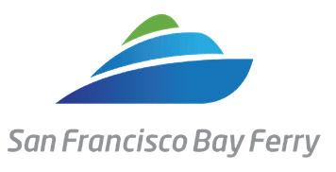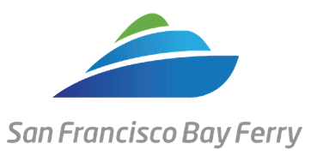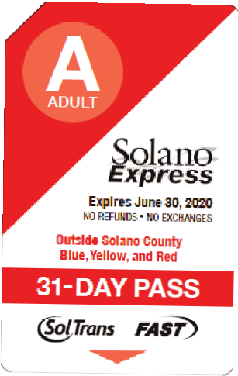

R Y B G

# Solano Mobility, a program of the Solano Transportation Authority, is welcoming back Solano Express riders with this special limited- time offer. Riders who purchase a 31-Day Pass can receive a Clipper Card ($125 cash value, limit one per household).

All Solano County workers and residents aged 18 and over are eligible

Use on regional transit service on Solano Express, San Francisco Bay Ferry, and BART

# For more information and to sign up, please visit [www.solanomobility.org](http://www.solanomobility.org/),call 800-535-6883, or use the QR code below.

Submit your application with proof of purchase.

Please allow two weeks for processing and mailing.

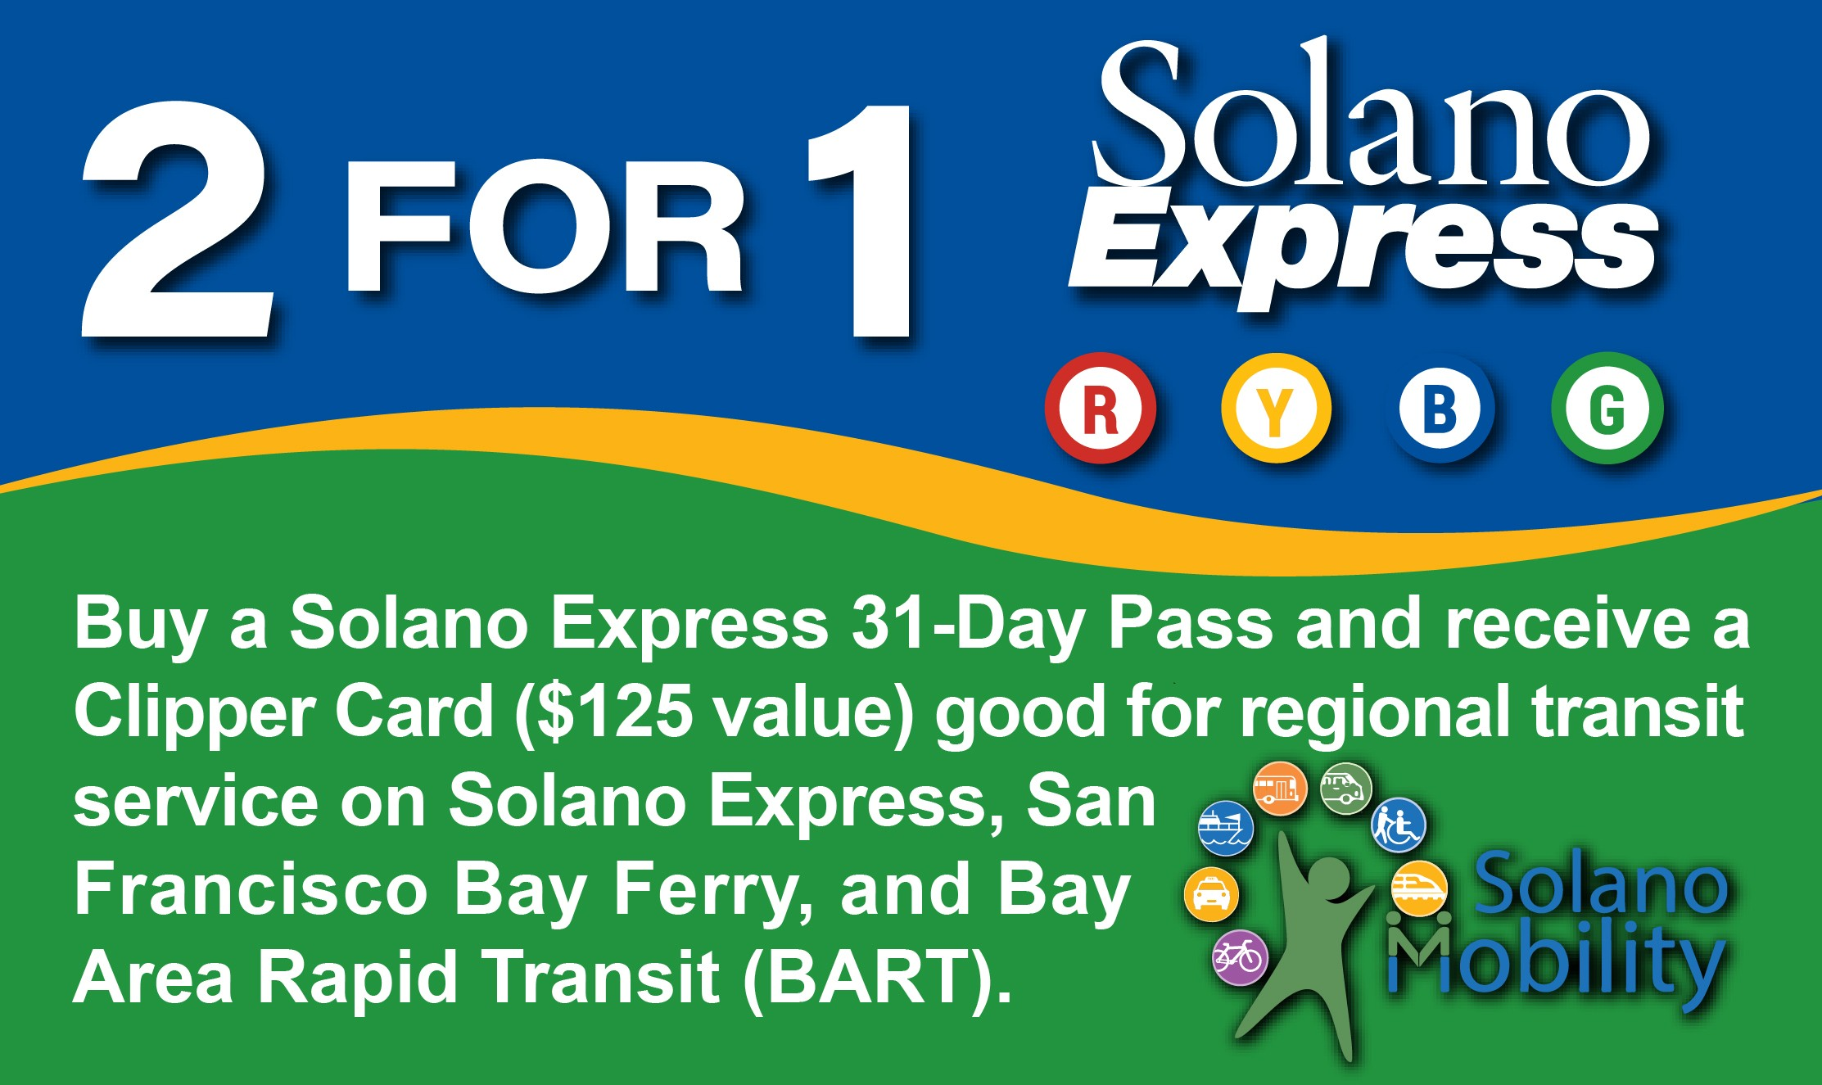

**Apply for a Clipper Card**

Print and complete this form. Return it with a copy of your receipt to the SolTrans or FAST customer service office or mail to:

**Solano Mobility**

**423 Main Street**

**Suisun City, CA 94585**

*All information is required to apply for a* ***Clipper Card***

### How many days a week do you take Solano Express? What Solano Express line (Red/Yellow/Blue/Green) do you take? How do you get to the bus stop?

❑ Drive myself  Carpool  Walk  Get dropped off

❑ Bike  Other (Specify):

### When you don’t use transit to get to work, what mode of transportation do you use most often?

❑ Drive myself  Walk  Get ride from coworker or family

❑ Bike  Ride sourcing service (i.e. Uber, Lyft, Scoop, Carzac, Waze, 511, other)

❑ Other (Specify):

**Contact Information**: ***(all fields are required)***

**First and Last Name**

**Daytime Phone Email**

Once your eligibility is confirmed, the Clipper Card ($125 cash value) will be mailed to you.

#### You are eligible if you:

* Live or Work in Solano County, and
* Are 18 years of age or older

## 2 FOR 1 Rules

* One (1) Clipper Card per household, while funding is available.
* If you have already participated in this Solano Mobility transit incentive program, you are ***NOT*** eligible for another offer.
* We may require verification of the information you provide.
* Solano Express and Solano Mobility reserve the right

to make any changes or to terminate this promotion at any time without prior notification.

* You agree to be signed up to receive the Solano Mobility email newsletter and agree to complete a post-program survey.

## QUESTIONS: Call 800-535-6883

*rev: 12/2024*

**Home Address *(P.O. Boxes not accepted)* City Zip**

**Employer Information**: ***(all fields are required)***

**Employer Name**

**Employer Address *(P.O. Boxes not accepted)* City Zip**

**Work Site Address (P.O. Boxes not accepted)**

### Acknowledgment:

I read the eligibility and promotion rules listed, and I verify the information submitted is correct. I agree to complete a post program survey from Solano Mobility following my participation in this promotion.

Signature Date

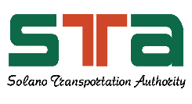

### Icon Description automatically generatedPass Amount:

31-Day Pass:  Reduced Fare/SDM Blue/Green/Red/Yellow: $57.00

* Out of County Blue/Green/Red/Yellow $114.00

*All stated limitations apply. Completion of this application does not guarantee delivery/receipt of a Clipper Card. Applicants must meet all qualifications listed and be approved by Solano Mobility.*